In the name of God

EE 432 Lab3 : Fading

Name: Mohammad Chahardori (Student ID: 11632753)

Partner: Richard Osorio

Due Date: 09/30/2020

Description:
Purpose of the Lab:
In this lab we are supposed to observe and experiment:
• The small-scale fading of a radio frequency channel in distance around lambda
• The spatial variations and statistics of real fading and the analysis of fading
• Compare the behavior of real fading to the model derived from Rayleigh fading equation
In this lab we should learn the effect of fading due to interaction of several fields received with different directions and phases in our wireless communication channel without line-of-sight. We have used the online data provided based on previous measurement. However, based on the data provided to us we realized that a field transmitter transmitting at $f=915 MHz$ was set up at the static point outside the measurement room in a way there is no line of sight between transmitter and receiver. Then using an ISM field strength meter, the received power was recorded every 2 inch in X and Y coordination for a square of 16 inch * 16 inch which includes 64 points. Since 16 inch = 40 cm which is in order of transceiver wavelength λ which is 33 cm, we expect to see the effect of fading between points with small distances even lower than λ in this experiment.
Procedure:
As explained before, the ISM transmitter is placed outside the room with no line of sight. An ISM field strength meter has been used to measure the received power on a square grid at two-inch intervals for a total of 64 field samples. To provide a time invariant environment we expect to have everyone remain in the same place during the measurements.
Analysis:
The measured power in dBm in our experiment is as follow:

We used Matlab file A.1 to assign the proper locations (X and Y) to the measured powers. We produce contour plots of field strength in dBm vs location using contour command in A.1 Matlab file as shown in Figure. 1.

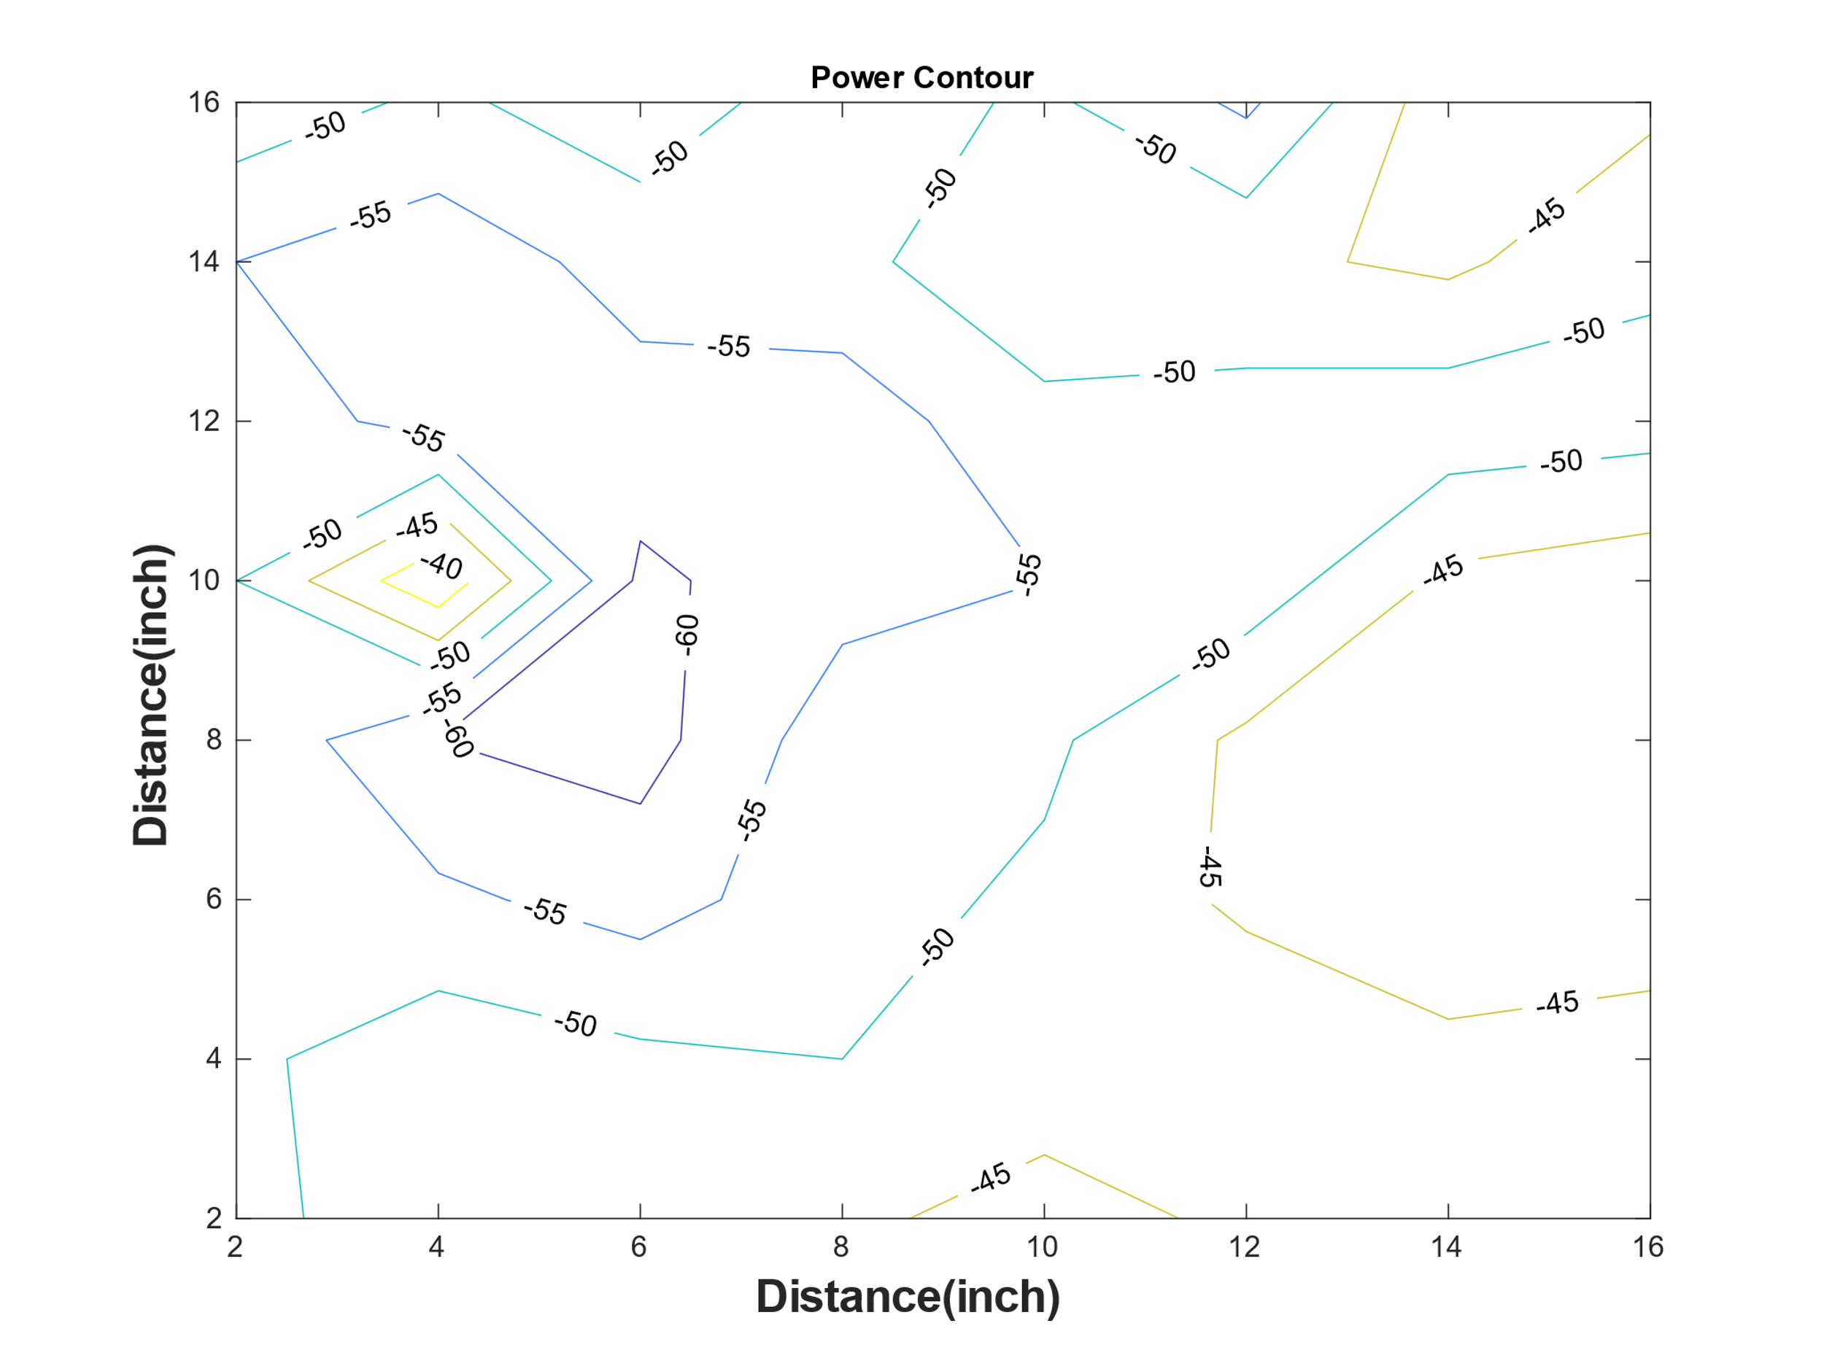
Figure.1. Power Contour
as we can see in Figure 1 variation in the received power even in this small distance which is smaller than λ is from -40dBm to 60dBm which is around 20 dB. Also in very small distance as small as 2 inch ( for example when X= 4 inch and Y changes from 10 inch to 12 inch) we can see up to 10 dB variation in the received power.
Since the Rayleigh distribution is correspond to voltage distribution of the received signals, in A.1 we converted the above powers in dBm to voltage amplitude using:
(1)
Then to make the histograms of these voltages first we reorganized the voltages from an $8×8$ matrix to a 64-element vector and then plot the histograms of this vector using Matlab command “hist”.
To realize how well the Rayleigh distribution can model the behavior of voltage distribution with fading environment we have plotted the diagram related to Rayleigh distribution with difference $σ$ and scaling Factor to match the histogram to the best point.
The best $σ$ is around 0.6 mV which is also equal to the $σ$ calculated from voltages measured in this experiment. Also we realized that the best scaling Factor matching the Rayleigh distribution and our histogram is around Scale Factor = 48 in our experiment. In Figure 2 the histogram and the best matched Rayleigh distribution have been shown.
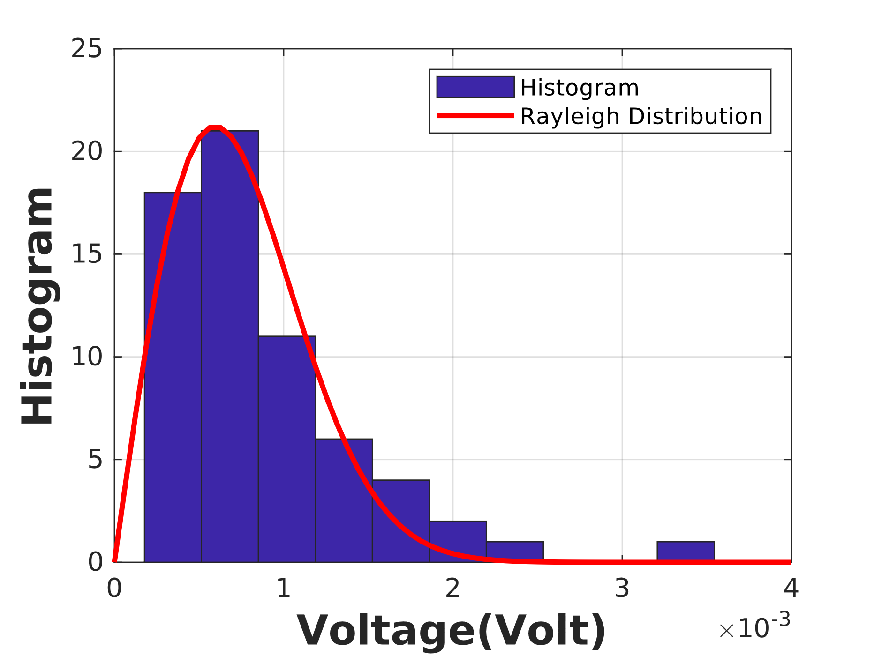
Figure.2. Histogram and Rayleigh distribution
As we can see the histogram has a skewed bell-shaped pattern which is matched very well with the Rayleigh distribution shown in figure 2 after the scaling of Rayleigh distribution. This shows that the voltage distribution due to fading has very similar behavior to Rayleigh distribution as we expected based on the course material.
Conclusion and discussion:
Based on Figure 1 variation in the received power even for small distances in order of 0.2 λ is more than 10 dB due to the fading. Also Based on figure.2 the voltage histogram has a skewed bell-shaped pattern which is matched very well with the Rayleigh distribution as discussed in the class.

Appendix A.1
Matlab Code:
clear all
close all

%++++++++++++++++++++++++++++++++++++++++++++++++++++
% Initialization of Parameter
% Input power Matrix
%++++++++++++++++++++++++++++++++++++++++++++++++++++

Power_Received = -1 *[
52 46 45 46 43 46 49 49;
51 47 49 50 48 49 46 48;
53 54 57 52 49 44 42 41;
51 60 62 52 51 44 41 40;
50 36 61 57 55 53 44 42;
52 57 57 58 51 52 53 52;
55 58 53 51 47 46 44 49;
47 51 47 53 49 56 42 44;
]

%++++++++++++++++++++++++++++++++++++++++++++++++++++++++++++++++++++++
% plotting the Power Contours
%++++++++++++++++++++++++++++++++++++++++++++++++++++++++++++++++++++++

x = 2:2:16;
y = 2:2:16;
[X,Y] = meshgrid(x,y);
figure(1)
[C,H] = contour(X,Y,Power_Received)
clabel(C,H);
title('Power Contour')
xlabel('Distance(inch)','fontweight','bold','fontsize',16);
ylabel('Distance(inch)','fontweight','bold','fontsize',16)

%++++++++++++++++++++++++++++++++++++++++++++++++++++
% Calculating received Voltages from Powers
%++++++++++++++++++++++++++++++++++++++++++++++++++++

Volatge_Received = sqrt ((50/1000) * 10 .^(Power_Received ./ 10));

%++++++++++++++++++++++++++++++++++++++++++++++++++++
% Converting Matrix to Vector
%++++++++++++++++++++++++++++++++++++++++++++++++++++

kk=1;
for ii = 1 : 8;
for jj = 1 : 8;
Volatge_Received_Vector (kk) = Volatge_Received (ii,jj);
kk = kk +1
end
end
Volatge_Received_Vector

Sigma = sqrt (var(Volatge_Received_Vector))

%++++++++++++++++++++++++++++++++++++++++++++++++++++++++++++++++++++++
% plotting the voltage Histogram
%++++++++++++++++++++++++++++++++++++++++++++++++++++++++++++++++++++++

figure(2)
hist(Volatge_Received_Vector)
hold on

%++++++++++++++++++++++++++++++++++++++++++++++++++++++++++++++++++++++
% Producing the Rayleigh Distribution curve
%++++++++++++++++++++++++++++++++++++++++++++++++++++++++++++++++++++++
V = (0 : 4/64 : 4)*1e-3;
Sigma = sqrt (var(Volatge_Received_Vector))
%Sigma = 0.0006
Pv = V .* exp(-V.^2/(2*Sigma^2))/(Sigma^2)/48;

%++++++++++++++++++++++++++++++++++++++++++++++++++++++++++++++++++++++
% plotting the Rayleigh Distribution
%++++++++++++++++++++++++++++++++++++++++++++++++++++++++++++++++++++++
plot(V,Pv,'-r','LineWidth',2 )
xlabel('Voltage(Volt)','fontweight','bold','fontsize',16);
ylabel('Histogram','fontweight','bold','fontsize',16)
grid on
legend('Histogram', 'Rayleigh Distribution', 'Location','northeast','NumColumns',1)

